**13 . Research Question:**

Use the Bonferroni method to construct simultaneous confidence intervals for :

 to see whether there are differences in attitude toward the mobility type of handicaps.

**Answer:**

**Amputee v Crutches:**

Based on the bonferroni method, the amputee and crutches 95% family-wise comparison is -3.009 to 0.025. This interval contains zero, leading us to potentially believe there is no difference. However, a formal hypothesis test should be in order to confirm this assumption.

Thus, based on the bonferroni procedure used, we would expect subsequent procedures to contain the difference of the mean at least 95% of the time.

**Amputee v Wheelchair:**

Based on the bonferroni method, the 95% confidence interval shows that zero is a plausible value with an interval of -2.431 to 0.603.

**Crutches v Wheelchair:**

Differences in the crutches and wheelchair groups are not considered significant utilizing the Bonferroni method (and even the Tukey method). Indeed, zero is in the at least 95% confidence interval from -0.939 to 2.095.

14. Handicap Study. Examine these data with your available statistical computer package. See what multiple comparison procedure are available within the one-way analysis of variance procedure. Verify the 95% confidence interval half widths in Display 6.6.

|  |  |  |
| --- | --- | --- |
| **Method** | **Book** | **SAS** |
| LSD | 1.233 | 1.233 |
| Dunnett | 1.545 | 1.545 |
| Tukey Kramer | 1.735 | 1.732 |
| Bonferroni | 1.794 | 1.794 |
| Scheffe | 1.957 | 1.957 |

All confidence interval half widths are displayed above in the table from SAS output. All are exactly the same or reasonably acceptable (Tukey Kramer). Code below:

**PROC** **GLM** data = handicap;

CLASS handicap;

MODEL score = handicap;

MEANS handicap / tukey scheffe bon LSD dunnett('None') CLDIFF;

**RUN**;

3. Problem 21

Use the Tukey-Kramer procedure to compare every group to every other group. Which pairs of means differ and by how many dollars?

All comparisons of education are significantly different except for 16 years compared to greater than 16 years according to the tukey multiple group comparison:

As noted by the confidence intervals above, insignificant comparisons contain zero in their 95% confidence interval. The largest difference in mean incomes, as expected, is the >16 category compared to the <12 category.

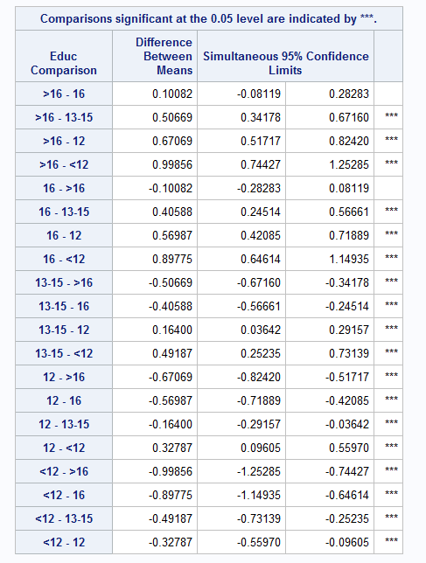

b) Use the Dunnett procedure to compare every other group to the group with 12 years of education. Which group means apparently differ from the mean for those with 12 years of education and by how many dollars?

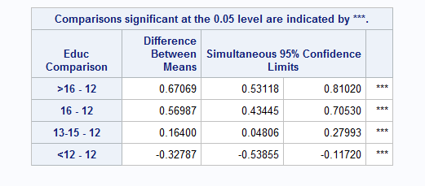

According to the Dunnett procedure, all comparisons are significantly different from the control group of 12 years.

If we were only comparing groups to 12 years of education as a control, we would utilize the Dunnet procedure rather than the tukey test to give a more precise confidence interval.

SAS Code:

**data** handicap;

infile '\\Client\C$\Users\patrickcorynichols\Desktop\Data Science\Stats\Data Sets\case0601.csv' DLM = ',' FIRSTOBS = **2**;

INPUT Score Handicap $;

**RUN**;

**PROC** **SORT** data = handicap;

BY handicap;

**RUN**;

**PROC** **BOXPLOT**;

Plot score*handicap;

**RUN**;

**PROC** **UNIVARIATE** data = handicap;

CLASS handicap;

VAR score;

QQPLOT;

HISTOGRAM;

**RUN**;

**PROC** **means** data = handicap;

CLASS handicap;

VAR score;

**RUN**;

**PROC** **GLM** data = handicap;

CLASS handicap;

MODEL score = handicap;

MEANS handicap / tukey bon LSD;

**RUN**;

**data** income;

infile '\\Client\C$\Users\patrickcorynichols\Desktop\Data Science\Stats\Data Sets\ex0525.csv' DLM = ',' FIRSTOBS = **2**;

INPUT Subject $ Educ $ Income2005;

**RUN**;

**PROC** **GLM** data = income;

CLASS educ;

MODEL Income2005 = educ;

MEANS educ / tukey dunnett('12') CLDIFF;

**RUN**;